TEST REPORT -AMPHISOFT

1.

Topic: Basics of java Programming -Variables-Learning Resources

Link: <http://app.e-box.co.in/amphiSession/processSession/31540>

Defect: There are no subtitles in this video.

2. Topic: Basics of java Programming -Variables-Learning Resources

Defect: Subtitles are not matching the video.

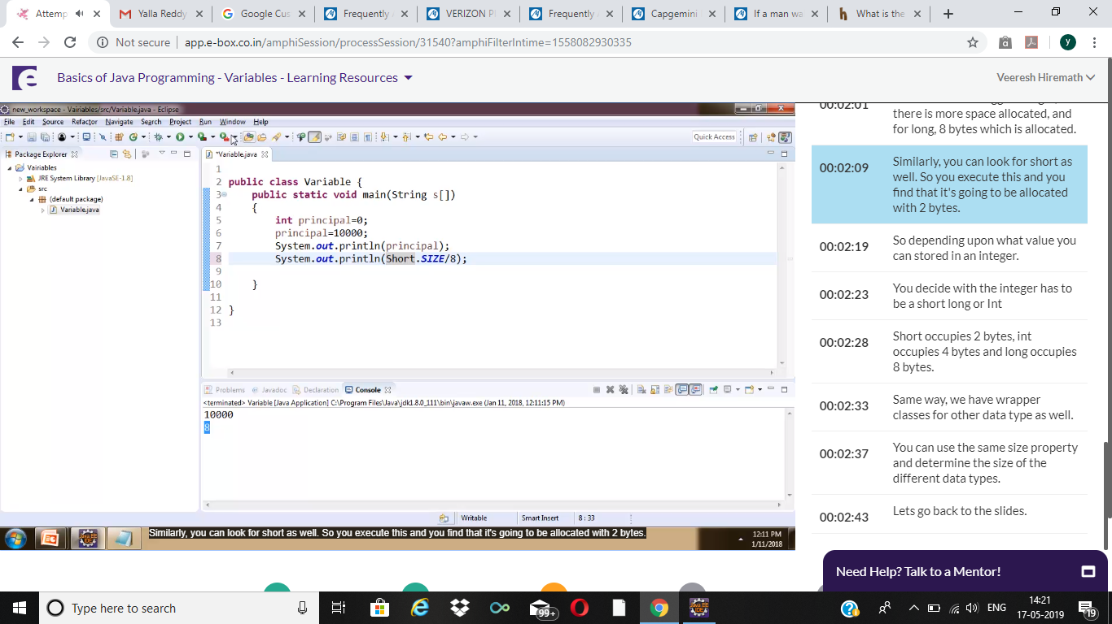

3. Topic: Basics of java Programming -Variables-Learning Resources

Defect: Subtitles are not matching the video.

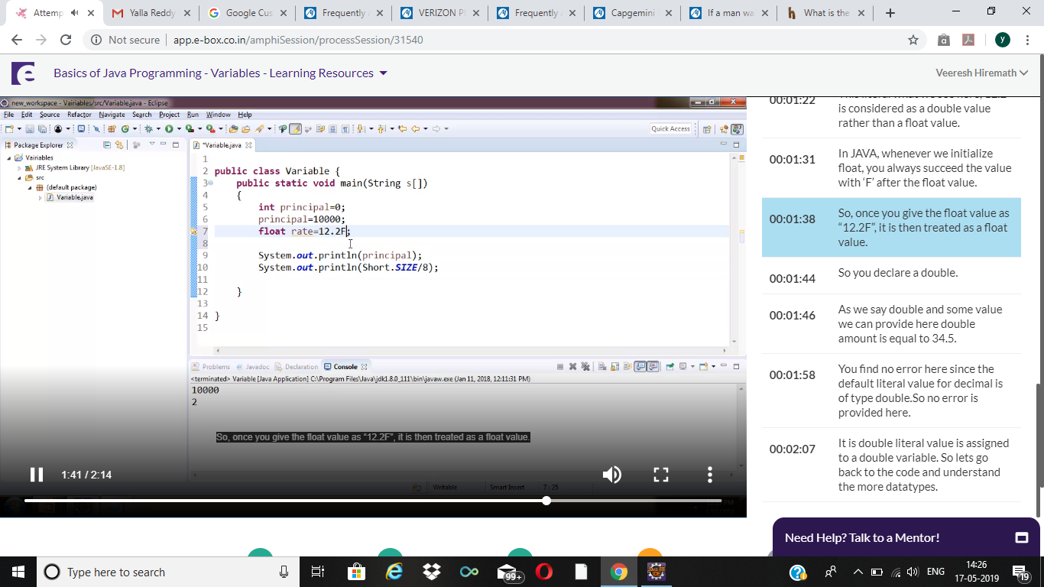

4. Topic: Basics of java Programming -Variables-Learning Resources

Defect: Subtitles are moving faster than the video.

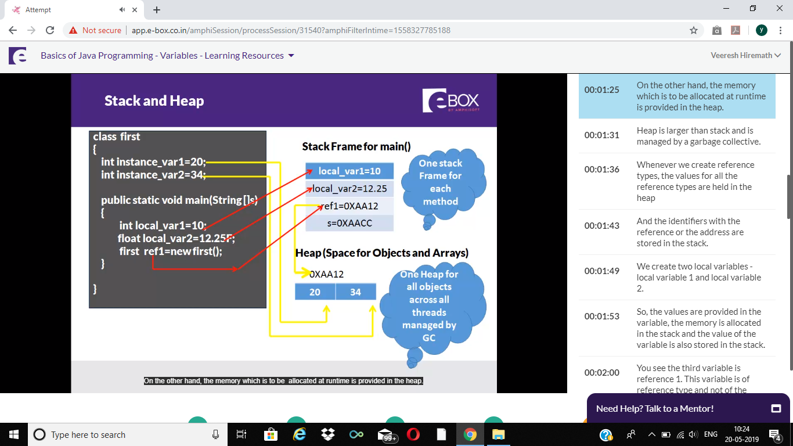

5.

<http://app.e-box.co.in/amphiSession/processSession/31541>

Defect: There are no subtitles for this video.

6. We are NOT able to open the Programs (menu). It is asking for licensing.

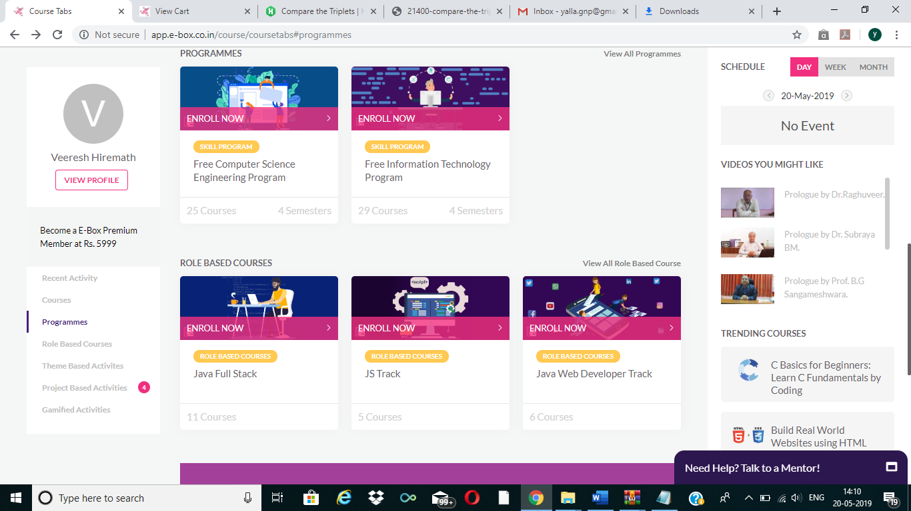

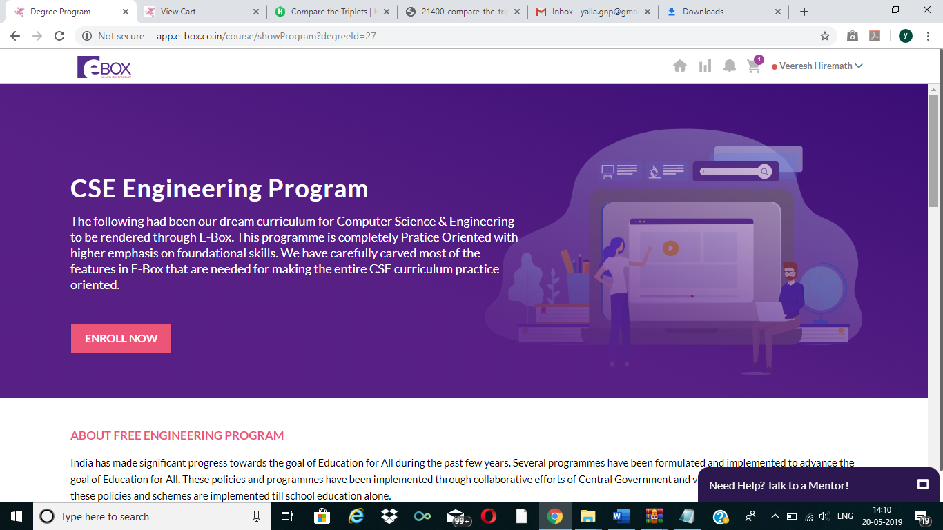

It is not allowing to do programs.